ar 3/26/2019

Student guide to self-registration

Contents

HOW TO REGISTER FOR CLASSES 3

❑ **MEET** 3

❑ **REGISTER** 4

❑ **VERIFY** 5

FAQ 6

Screenshots 7

# HOW TO REGISTER FOR CLASSES

## **MEET**

Sign up for an appointment on your advisors door. Before the appointment, use the MyGarrett portal (**my.garrettcollege.edu**) to do the following:

1. Complete digital **Registration Agreement** (for each semester you intend to register for)

The Registration Agreement form is located in the Course Registration area of the Student Tab. Be sure to select the appropriate term in the gray shaded area. If you are registering for more than one term (i.e. summer and fall), you will complete a Registration Agreement for each term.

1. Complete digital **Personal Information Update** (required for fall and spring only)

The Personal Information Update form is located in the Course Registration area of the Student Tab. Complete all areas as accurately as possible.

1. Use the **Course Search***\** area to find the classes you want to take. Have a schedule of classes written down and ready to discuss during the appointment.   
     
   *\*Note – you will not be able to view the course schedule when logged into the MyGarrett portal until you complete the Registration Agreement and Personal Information Update. You may still view the course schedule while not logged in.*

Also, take care of any **HOLDS** you may have on your account. You will not be able to self-register for courses with a HOLD.

Go to your scheduled advising appointment. During the appointment, discuss your academic plan, including the classes you wish to take next semester, with your advisor.

You ***MUST*** meet with your advisor to receive registration clearance.

**IMPORTANT** **– If applicable, discuss these uncommon course registrations with your advisor**

1. **CHANGING YOUR MAJOR** – If you wish to change your major, let your advisor know during your appointment. Your advisor will assist in completing the required paper forms that must go to the Office of Records and Registration to be processed. You are not able to change your major on the student portal yourself.
2. **REGISTERING FOR 2ND REPEAT COURSES** - During your appointment, your advisor will assist in registering for any 2nd course repeats (third course attempt) using the required paper form. These forms must be approved by the Dean of Academic Affairs and submitted to the Office of Records and Registration to be processed. *\*NEW - You may self-register for a 1st course repeat (second course attempt); a form is no longer required.*
3. **REGISTERING FOR WINTER OR SUMMER COURSES** – If you plan to register for an alternate semester, winter or summer, let your advisor know during your appointment. He or she must provide clearance for each term individually so that you may self-register.
4. **OTHER SPECIAL CIRCUMSTANCES** – Your advisor’s assistance may also be necessary for other special circumstances, such as: registering for more than 18 credits, independent study courses, along with others.

Once you have met with your advisor, addressed any special circumstances above, and received registration clearance, you may proceed to self-register for your remaining standard courses.

## **REGISTER**

Following your advisor meeting, **you have 48 hours** (2 days) to self-register for courses. After a period of 48 hours, registration clearance will be removed and you will need to meet with your advisor again to receive clearance. Be sure to register for classes ***AS SOON AS POSSIBLE*** after your advisor appointment to avoid classes filling up and clearance removal.

**HOW TO SELF-REGISTER**

1. **Log into My.GarrettCollege.edu** (At this point, you should have already completed the Registration Agreement and Personal Information Update. If you have not, do them now.)
2. **Register for courses**

There are two ways to register for courses in the Course Registration Area. *\*You will only be able to view the course schedule once you have completed the Registration Agreement and the Personal Information Update.*

* 1. **Add by Course Code** – allows you to quickly add courses you had previously identified by the course code (i.e. SPC101-02). If you and your advisor prepared a full schedule in advance, this is the best option.
     1. Check the term in the gray box; default is always fall or spring. If you plan to register for a summer or winter course, do those first, then proceed to fall or spring using these same steps.
     2. Click the Add by Course Code tab.
     3. Type the full index code, including the section number, for your first course into the box (SPC101-02 – *do not add the space between three letters and three numbers, system will automatically populate courses as you type, select your course as identified by the last two numbers or section number*).
     4. You may add courses one by one or all at once.
     5. Click Add Courses.
  2. **Course Search** – allows you to filter and search through the entire course schedule to find the courses you wish to choose. Use Course Search function of Course Registration area to find, select, and add your desired courses to your schedule.
     1. Check the term in the gray box; default is always fall or spring. If you plan to register for a summer or winter course, do those first, then proceed to fall or spring using these same steps.
     2. Use the various Course Search options (or select More Search Options for more) to find the classes you wish to register for. You can search by course title, course code (SPC 101 – *must add the space between three letters and three numbers*), time of day, day of the week, and more.
     3. When you have identified a course you wish to register for, click the Add Course box to the left of the Course Code and click Add Courses at the bottom of the screen. You may also click the blue course code link and click Add Course on the next screen.
     4. Proceed to find and register for all of your desired courses in the Course Search area.

Once you have clicked Add Courses, you will see status message at the top of the next screen. These messages may include a course add confirmation, course add warning, or an error message. **Pay close attention to all status messages.**

**Confirmation:**

* *Successfully added*

**Warning:**

* *Financial aid may not pay for this course, it is not in your program requirements and will not count towards financial aid enrollment status. See your advisor for more information.*
* *This course is a repeat of a previous registration. Financial aid may not pay for repeated courses.*
* *This course if full or students are already waitlisted. You are not fully enrolled in this course until the Office of Records and Registration notifies you of a seat opening and you accept.*

**Error:**

* *This registration exceeds the number of times you are allowed to repeat this course. See your advisor to request authorization to repeat.*
* *This course has a corequisite that is not met. See course description for corequisite details.*
* *Permission of instructor is needed. See your advisor for more information.*
* *Adding this registration would create an overload (greater than 18 credits). See your advisor to request authorization.*
* *A prerequisite for this course has not been met. See course description for prerequisite details.*
* *This course is already registered in this term, and it is not repeatable.*
* *This course is a course that may not be dropped. Contact your advisor.*
* *You do not have permission to Drop courses. See your advisor for more information.*

Contact your advisor for any messages you believe are inaccurate or if the messages prevent you from registering for your desired courses.

**If you need help during the self-registration process, visit the AASC in room 519 or the Tutoring Center in the library.**

## **VERIFY**

Once you’ve registered for your classes, your advisor will then approve your course selections **within 48 hours**. Courses that have been approved by advisor will appear as ***Current*** on your schedule and courses that are awaiting advisor approval will appear as ***Reserved***. If your courses are not approved after a few days, contact your advisor.

You may register for additional courses through the end of the add/drop period; however, you may not drop courses. To drop courses, you must see your advisor.

# FAQ

Below are several frequently asked questions regarding student self-registration.

1. Can I register myself for classes online?

YES, but you must first meet with your advisor.

1. How do I know who my advisor is?

Look under the Student tab on your MyGarrett portal.

1. How do I know what classes to take?

Use your Advising Worksheet on your MyGarrett portal, the College Catalog, and your advisor.

1. How many classes can or should I take?

Students may register for between 12-18 credits; somewhere around 15 credits per semester is recommended.

1. How do I register for classes online?

Read the instructions in this guide.

1. When should I register for classes?

Within 48 hours after meeting with your advisor.

1. Can I drop classes online?

No, you must see your advisor to drop or withdraw from a class.

1. Can I change my major online?

No, you must see your advisor to change your major.

1. What if I need help?

See the AASC in room 519, call 301-387-3715, or visit the Tutoring Center in the Library. Resources are also available in the MyGarrett portal (login, click Student tab, scroll down to Useful Forms area).

# Screenshots

1. **Log into MyGarrett portal**

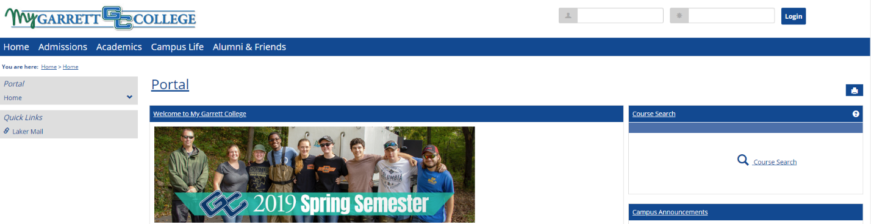

1. **Complete Registration Agreement**

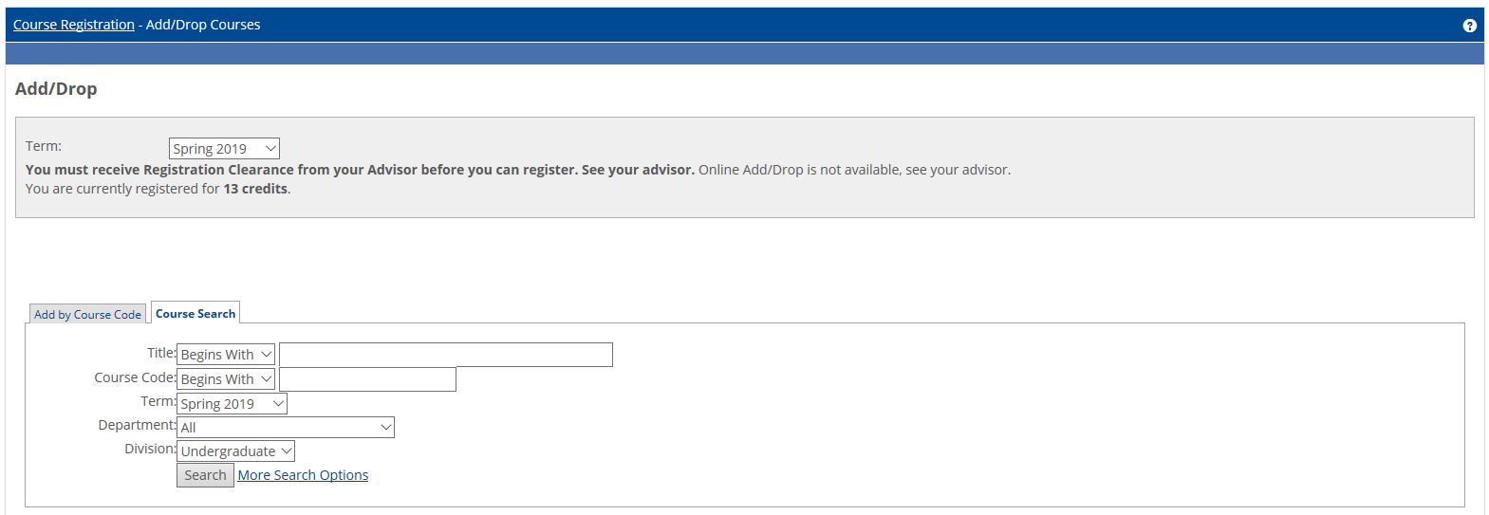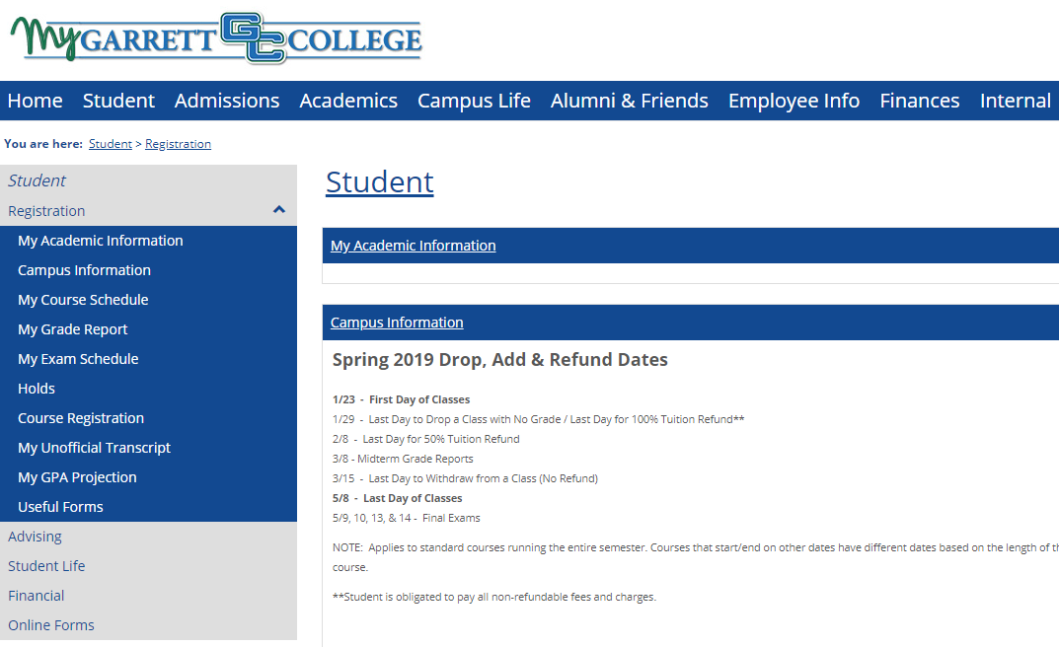

1. **Login**
2. **Click Student Tab**
3. **Click Registration dropdown menu**
4. **Click Course Registration**
5. **Select Complete Registration Agreement link and complete the agreement**
6. **Select Complete Personal Information Update and complete the update**

Complete Registration Agreement

Complete Personal Information Update

1. **Register for courses – ADD BY COURSE CODE**

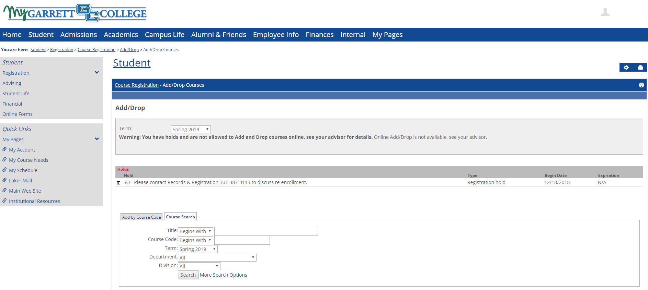

**Register for courses – COURSE SEARCH**



**Use search filters to narrow down the field of courses you are looking for.**

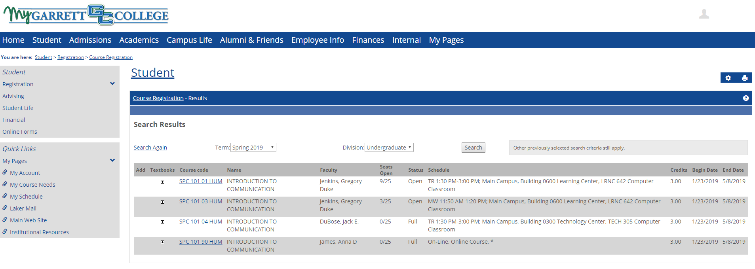

**Search results**



**To select a course to add, click inside the gray/white check box and click ‘Add Course’ at the bottom of the screen.**

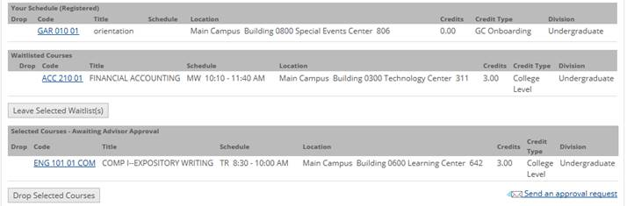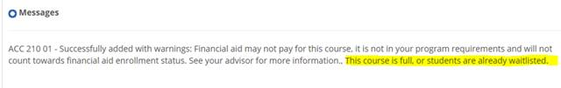

**Pay attention to the confirmation, earning, or error messages that appear as you self-register.**

1. **Verify Courses**

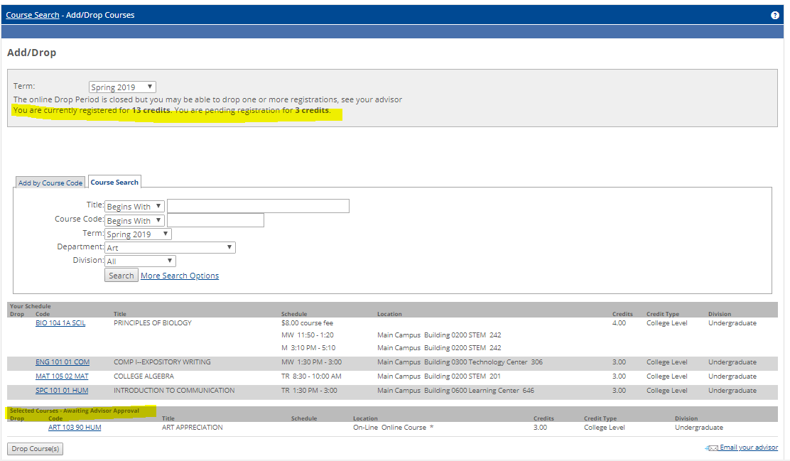

**Contact your advisor if your courses are not approved after 48 hours from the time you self-registered.**

**This course is still waiting for advisor approval.**

**Pay close attention to all status messages.**

**Advisor has approved these courses.**